chapter1 chapter2 chapter3 DOWNLOAD

**chapter1**



Mankombu Sambasivan Swaminathan, or M.S. Swaminathan, is known as the “Father of the Green Revolution in India”, birth details>date of birthWho are the family of Swaminathan? Personal life and death He was married to Mina

Swaminathan, whom he met in 1951 while they were both studying at Cambridge. They lived in Chennai, Tamil Nadu. Their three daughters are Soumya Swaminathan (a paediatrician), Madhura Swaminathan (an economist), and Nitya Swaminathan

(gender and rural development)familyt detailsSwaminathan, the son of a surgeon, was educated in India and at the University of Cambridge (Ph.D., 1952) as a geneticist. During the next two decades he held a number of research and administrative positions (mostly in the Indian civil service).Education DetailsBefore being conferred the Bharat Ratna, he was awarded the Padma Shri, Padma Bhushan, and Padma Vibhushan awards, as well as the H K Firodia Award, the Lal Bahadur Shastri National Award, and the Indira Gandhi Prize too. Swaminathan died on September 28, 2023, at the age of

98 years in ChennaiawardsM.S. Swaminathandied September 28, 2023,Death BACK

**chapter2**



Rabindranath Tagore (born May 7, 1861, Calcutta [now Kolkata], India—died August 7, 1941, Calcutta) Bengali poet, shortstory writer, song composer, playwright, essayist, and painter who introduced new prose and verse forms and the use of colloquial language into Bengali literature, thereby freeing it from traditionalbirthdetailsDwijendranath, Tagore's elder brother, was a poet and philosopher. The first Indian to be appointed to the hitherto all-European Indian Civil Service was another brother named Satyendranath. Jyotitindranath, another brother, was a writer, composer, and musician. His sister

Swarnakumari went on to publish novels.family details

BACK

**chapter3**

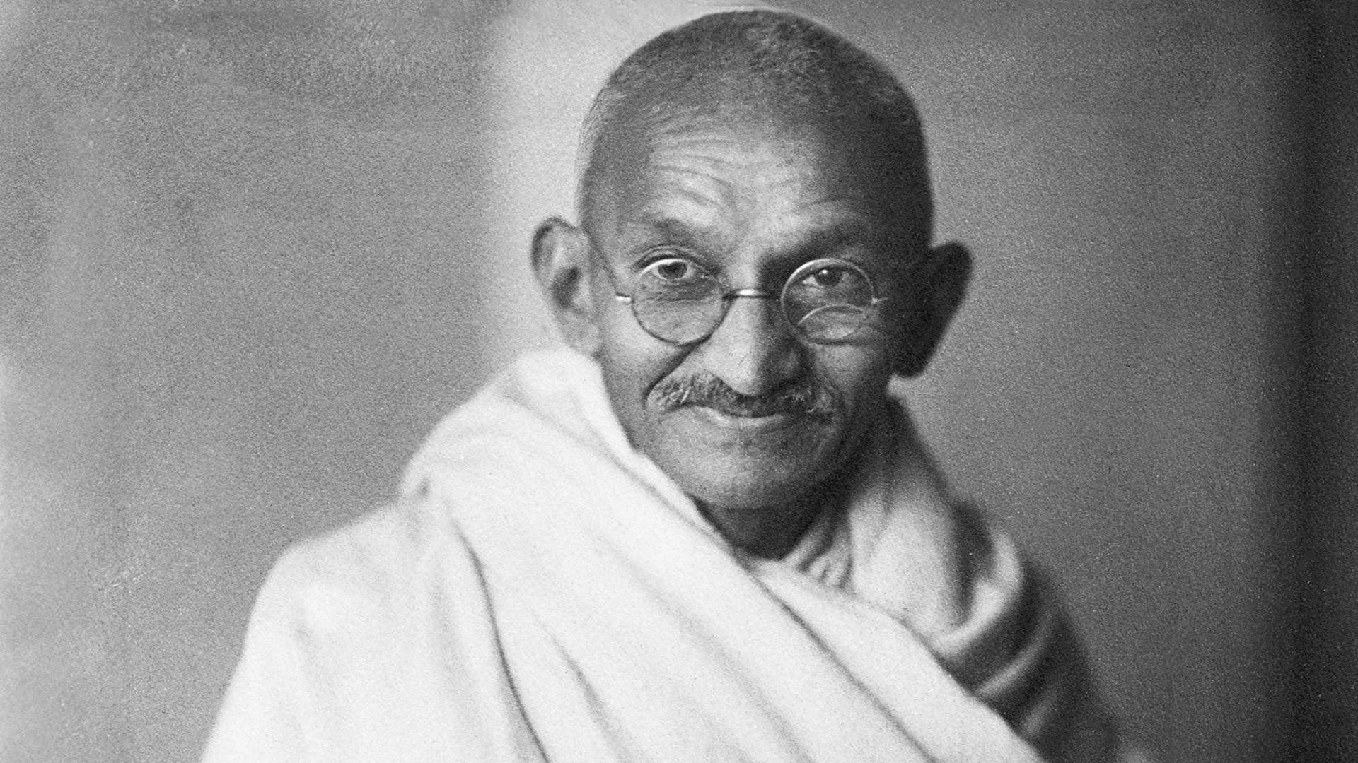Mohandas Karamchand Gandhi was an Indian lawyer, anti-colonial nationalist and political ethicist who employed nonviolent resistance to lead the successful campaign for India's independence from British rule. He inspired movements for civil rights and freedom across the world.

BACK